**CUSTOMER AND PHARMACIST APP**

**Student: Kenji Quik (1304332) and Matthew Cho (188515)**

This assignment uses NFC and SMS. This application is designed for pharmacist and clients. The pharmacist easily send reminders to the clients when medicine is ready to be picked up. The client can bring a NFC tag to the pharmacy, and pharmacist can easily monitor the prescribed medicine by tapping the tag with the smartphone.

The application consist of the following:

**NFC Scanner:**A NFC tag can easily be tagged by anyone that has the application on the phone. This can be done on any of the screen interface. When the phone used on a NFC Tag a hash tag can be seen. This hash tag can be then retrieve details of the medicine and client details.  
  
NFC tag picture

**Login interface:**  
Customer or Pharmacist can login on this screen if they have an account. The user can click the register button to register as a user.

The user needs to enter the following user details to successfully register a user account. The user can choose to either to make the account as a pharmacist or a client. These details are then updated to the php database.

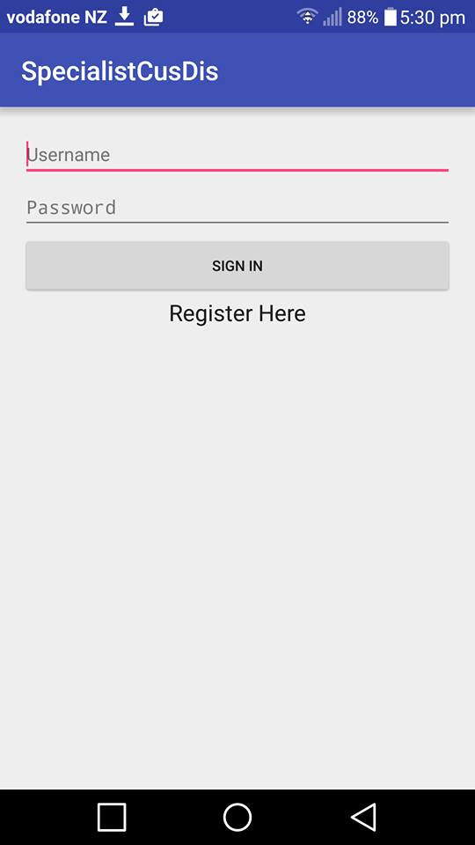 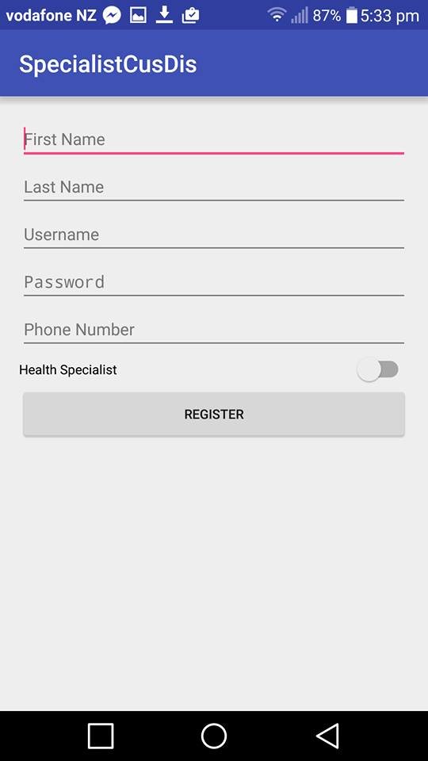

Implemented:  
The login detail are able to be retrieved using PHP with a database.

**Client Interface:**The client details are shown upon login.  
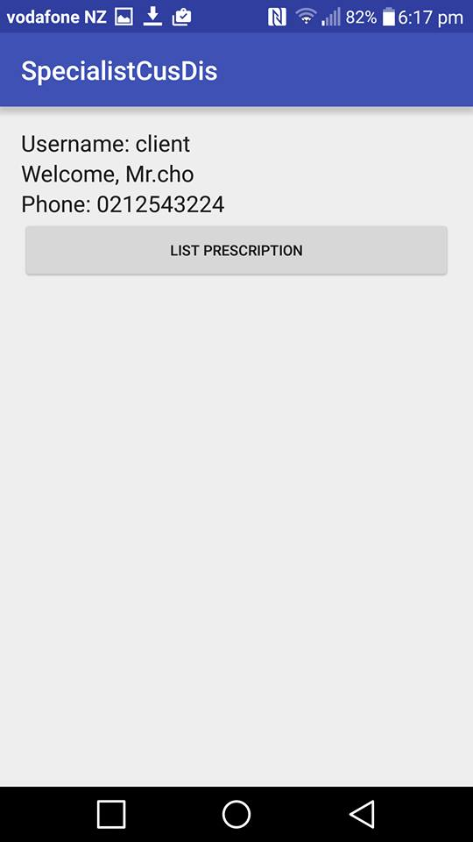

Prescription List:  
The customer can see what medicine the health specialist has prescribed to the client.   
When the client clicks the prescribed item, the client is prompted on a feedback form where the client can send back a feedback to the health specialist

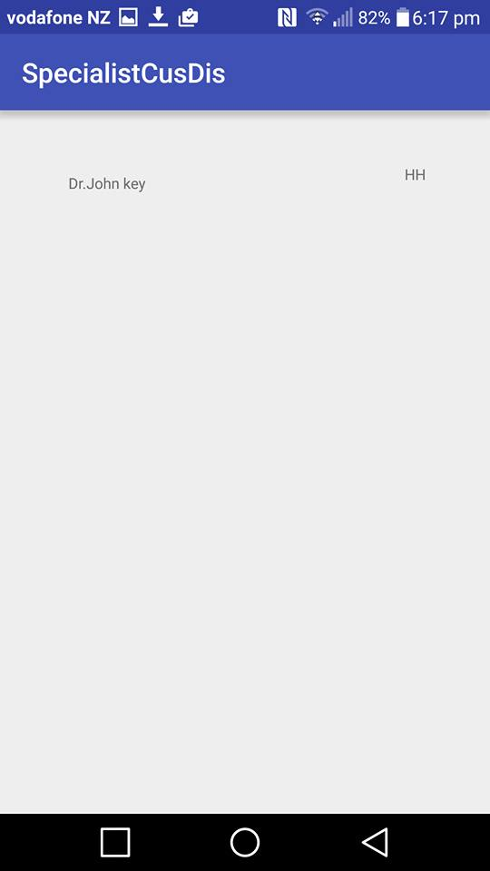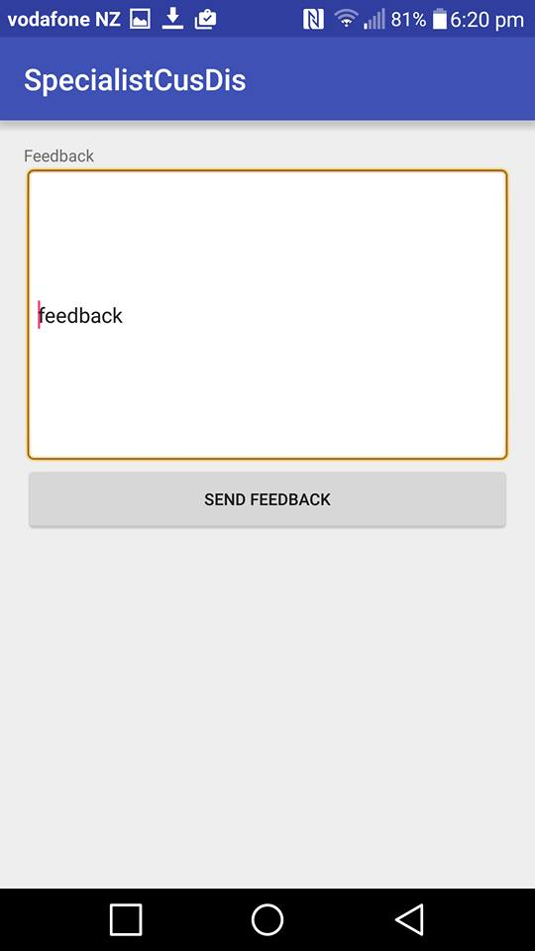

**Pharmacist Interface:**   
The pharmacist details are shown upon login. The pharmacy has two options to either create a prescription or show what’s the current clients and their prescriptions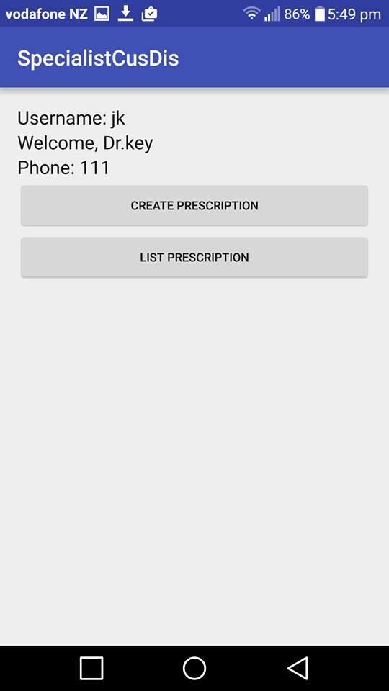

Create prescription:  
The health specialist can be able to issue a prescription to a client. The pharmacist will need to know clients details for it to show up on the clients “list of prescription” when they log in.

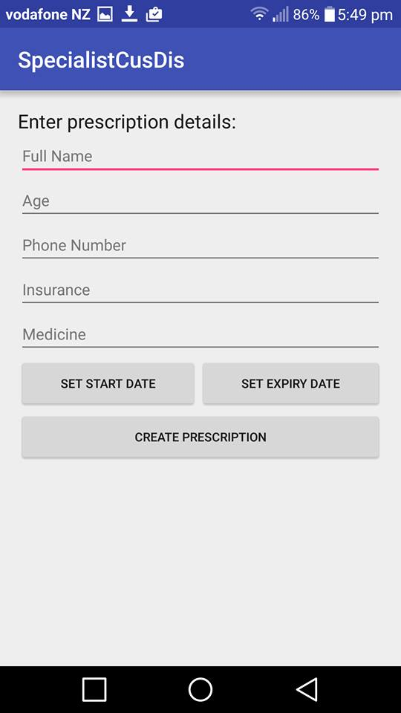

**Clients Prescriptions:**When entered into list of prescription the health specialist can see their clients medicine name and also their phone number.  
Upon clicking one of the client, the specialist can write the prescription to a NFC tag. The specialist can also send a reminder to the client by clicking the send reminder button. This will send an automated message to the client.

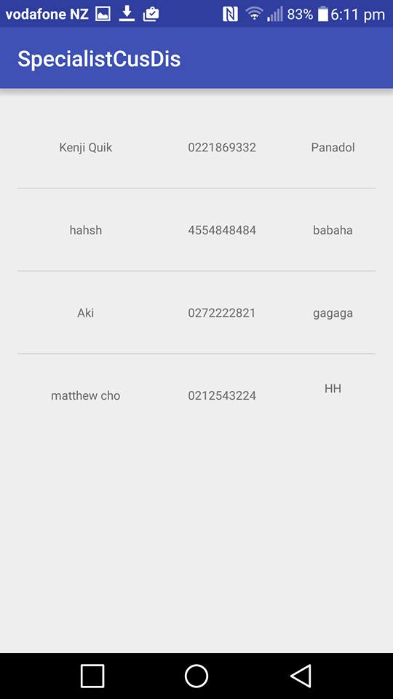 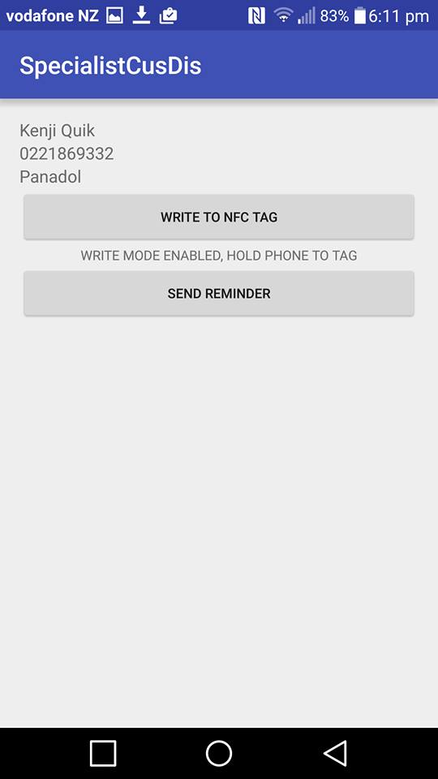 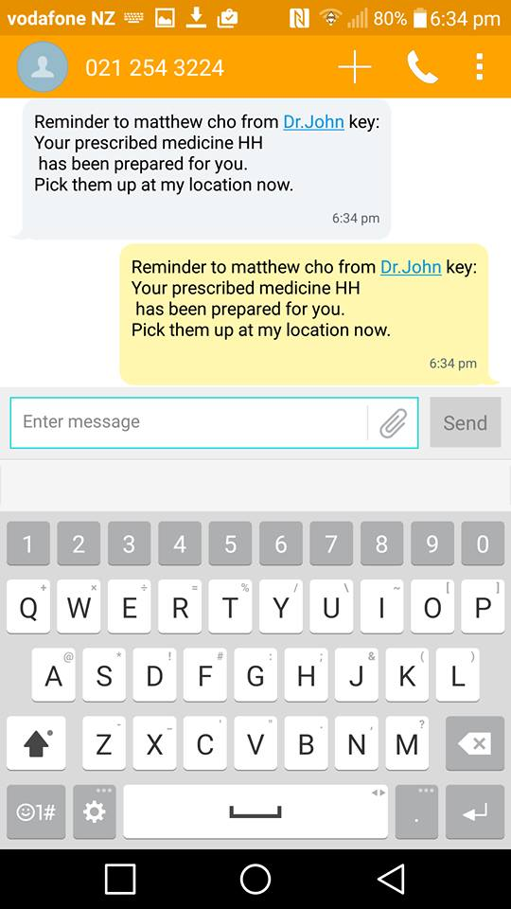

Implementations

NFC

When a prescription is selected, the PresOptionActivity allows pharmacist to write a hash which is used as a unique identifier in the database. Hence, when the NFC tag is tagged the NFCTaggedActivity allows all users tp identify the contents of the tag.

SMS

This technology is implemented to send a prepared message either a reminder for the customer or a feedback of the medicine to the pharmacist.

